**Cancer Cell Detection and Segmentation**

**Problem Statement**

The early stage cancer detection is required to provide proper treatment to the patient and reduce the risk of death due to cancer as detection of these cancer cells at later stages lead to more suffering and increases chances of death. Cancer cells have huge variations in shape and size. Their nucleus is darker and larger than a normal cell. Some blood tests used to test the presence of cancer cell are: Blood Protein Test, Complete Blood Count (CBC), and Tumor Marker Test. Detecting a cancer cell in a microscopic image requires segmenting the image into multiple regions. Then filtering out those regions that are representative of cancer cells. But cancer cells have the pro-survival characteristic that makes them difficult to differentiate. Also, due to loss of contact inhibition, they grow in uncontrolled manner while normal cells stop when they increase beyond the body requirement limit. So, at early stage detection of these cancer cells because of too less size is difficult.

**Background**

### Researcher’s efforts have made it possible to detect cancer cells not only by going through radioactive or magnetic test rather it can be detected by simple blood test. However, detecting a tumor cell among all normal cells is like looking for 1 molecule in 1000. The new blood-based technique Strand LB is a liquid biopsy test that is conducted by taking blood sample hence it lowers the patient’s diagnosis discomfort. After taking blood samples tumor can be detected by sensitive digital technology.

### The advantage of this technique is that it is a common test for detecting all kind of cancers.

# Other researchers worked on image analysis of the cancer cell to accelerate diagnosis. Before analyzing the CT or MRI images for cancer cell detection some pre-processing is done and morphological operations are performed. Some has detected and segmented the cell using Sparse Reconstruction and Stacked Denoising Autoencoders. In that variation in shape is handled by sparse reconstruction and autoencoder was trained with discriminative losses and structured labels for segmentation.

### Some researchers have used automatic counting of cell in microscopic images using CNN. Others used different resolution images to identify cancer cells. Some has segmented the cell using marker-based watershed.

**Methodology**

The architecture of cancer cell Detection and segmentation is shown in Fig1.

**Step 1: Data collection and dataset preparation**

In this step, several microscopic images containing cancer cell will be collected and annotated with expert help.

**Step 2: Developing a CNN based cancer detection**

Popular pre trained Inception and Resnet models will be explored on cancer cell images.

**Step 3: Implementation and Experiment**

In this step, the detected cancer cells will be segmented out and the model will experiment with different images containing cancer cell.

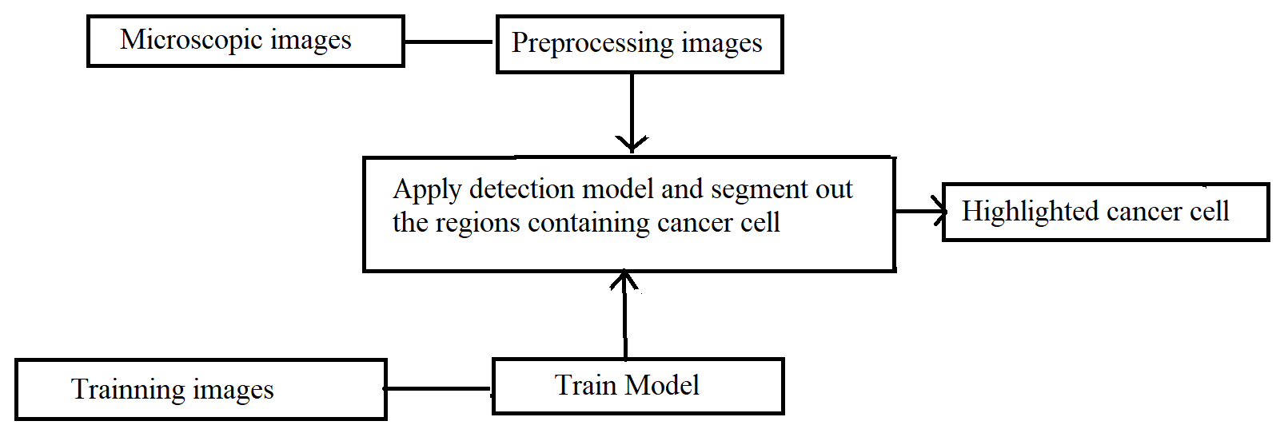

Fig 1. Cancer Cell Detection and Segmentation

**Experimental Design**

**Dataset**

UCSB Bio-Segmentation

Bio GPS dataset

NCBI dataset

NCI data catalog

NTU dataset

ALL-IDB image datasets

TCGA dataset

AMIDAI13 dataset

https://www.kaggle.com/paultimothymooney/blood-cells

**Evaluation Measures**

Measures such as accuracy and Mean Average Precision (MAP), the recall will be computed by comparing the detected cancer cell and ground truth from the datasets.

**Software and Hardware Requirements**

**Software:**

Anaconda

Python

Keras

Tensor flow

OpenCV

**Hardware:**

NVIDIA GPU